WMC PRACTICAL 5

AIM – To study CDMA spreading/despreading techniques and apply it on the Communication link in MATLAB

THEORY –

**MULTIPLE ACCESS TECHNIQUES**

* Multiple access techniques are used to allow a large number of mobile users to share the allocated spectrum in the most efficient manner.
* As the spectrum is limited, so the sharing is required to increase the capacity of cell or over a geographical area by allowing the available bandwidth to be used at the same time by different users.
* And this must be done in a way such that the quality of service doesn’t degrade within the existing users.
* A cellular system divides any given area into cells where a mobile unit in each cell communicates with a base station.
* The main aim in the cellular system design is to be able to increase the capacity of the channel i.e. to handle as many calls as possible in a given bandwidth with a sufficient level of quality of service.

These includes mainly the following:

1. Frequency division multiple-access (FDMA)
2. Time division multiple-access (TDMA)
3. Code division multiple access (CDMA)

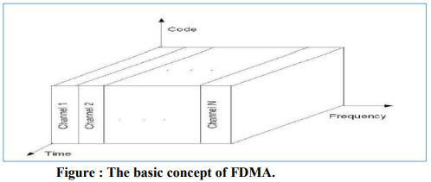

* Each individual user is assigned a pair of frequencies while making or receiving a call as shown in Figure.
* One frequency is used for downlink and one pair for uplink. This is called frequency 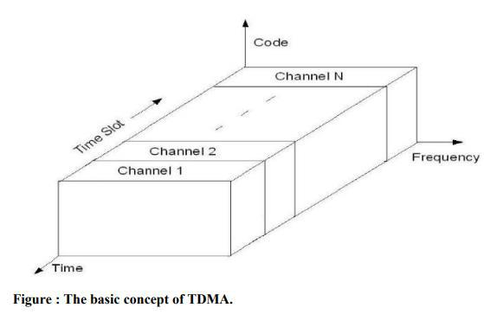division duplexing (FDD).
* In digital systems, continuous transmission is not required because users do not use the allotted bandwidth all the time. In such cases, TDMA is a complimentary access technique to FDMA.
* Global Systems for Mobile communications (GSM) uses the TDMA technique.
* In TDMA, the entire bandwidth is available to the user but only for a finite period of time. The users are allotted time slots during which they have the entire channel bandwidth at their disposal, as shown in Figure
* In CDMA, the same bandwidth is occupied by all the users, however they are all assigned separate codes, which differentiates them from each other shown in Figure
* CDMA utilize a spread spectrum technique in which a spreading signal (which is uncorrelated to the signal and has a large bandwidth) is used to spread the narrow band message signal 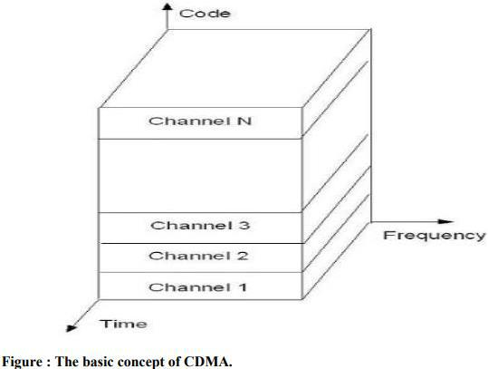

MATLAB CODE –

clc;

clear all;

close all;

for k=1:3

ber = [];

input_signal = randi([0,1],1000,1);

%PN sequence

if k==1

H = commsrc.pn('Genpoly',[3 2 0],'InitialStates',[0 0 1],'CurrentStates',[0 0 1],'Mask',[0 0 1],'NumBitsOut',8);

pn = generate(H);

elseif k==2

H = commsrc.pn('Genpoly',[4 3 0],'InitialStates',[0 0 0 1],'CurrentStates',[0 0 0 1],'Mask',[0 0 0 1],'NumBitsOut',8);

pn = generate(H);

else

H = commsrc.pn('Genpoly',[5 3 0],'InitialStates',[0 0 0 0 1],'CurrentStates',[0 0 0 0 1],'Mask',[0 0 0 0 1],'NumBitsOut',8);

pn = generate(H);

end

%expanding msg data

msg_signal = repmat(input_signal,[1,8]);

%pn = repmat(pn,[1000/8,8]);

for i=1:size(msg_signal,1)

for j=1:8

spreaded_data(i,j) = xor(msg_signal(i,j),pn(j));

end

end

spreaded_data = reshape(spreaded_data,8000,1);

spreaded_data = reshape(uint8(spreaded_data),size(msg_signal));

%qpsk mod nd demod

for snr=-10:10

M = 4;

m = log2(M);

X1 = spreaded_data(:); %reshape(x,[],1)%

zer_pad = rem(length(X1),m);

if(zer_pad~=0)

X1 = [X1;zeros(m-zer_pad,1)];

end

INPUT = reshape(X1,length(X1)/m,m);

INPUT = bi2de(INPUT);

y = pskmod(double(INPUT),M);

y = awgn(y,snr);

z= pskdemod(y,M);

z1 = de2bi(z,m);

if(zer_pad~=0)

z1 = z1(1:end-(m-zer_pad));

end

output = reshape(uint8(z1),size(spreaded_data));

output = reshape(output,[1000,8]); %output

for i=1:size(msg_signal,1)

for j=1:8

despread_data(i,j) = xor(output(i,j),pn(j));

end

end

msg_rx = round(mean(despread_data,2));

ber = [ber mean(abs(msg_rx-input_signal))];

if k==1

Ber1 = ber;

elseif k==2

Ber2 = ber;

else

Ber3 = ber;

end

end

end

snr = -10:10;

plot(snr,Ber1,snr,Ber2,snr,Ber3);

legend('Signal-1','Signal-2','Signal-3');

OUTPUT –

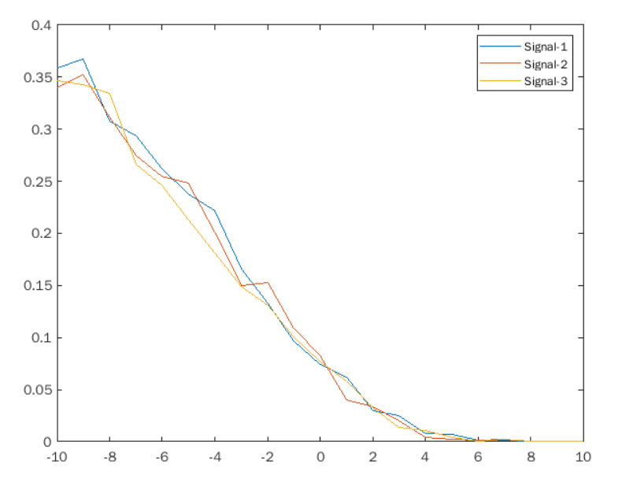

CONCLUSION –

In this practical we have seen the CDMA spreading and despreading techniques and we also plotted BER vs SNR for three messages.